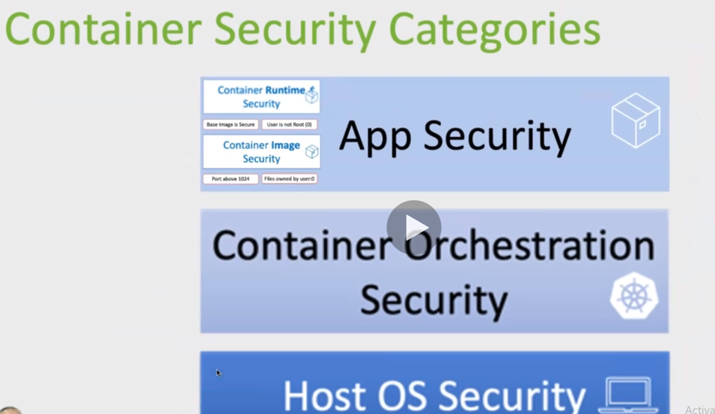

Container runtime should not use root user and that’s the reason we should need to use port above 1024. This leads us to change even nginx default port from 80 to some different port like 8080.